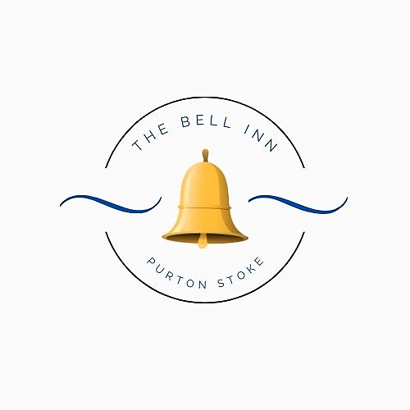

***Kaileigh & Guy Tasker; formerly of The Three Crowns in Brinkworth, The Weighbridge Brewhouse, The Golden Swan and The Langley Tap welcome you to The Bell Inn, Purton Stoke.***

***Our goal; is to create classic British dishes with a twist and re-introduce you to some old favourites!***

***We hope you enjoy your meal.***

**All our dishes are homemade; please let us know if you have any dietary requirements or allergies, as some of our dishes can be adapted.**

**Every effort is made to ensure our dishes are allergen free, but there may be a possibility of cross contamination in a busy kitchen environment.**

***Please note a discretionary 10% service charge will be added to groups of 10 people or more.***

***STARTERS***

**Bowl Of Marinated Bosciola Olives (V) £5**

**Famous Crispy Cheese Dumplings ~** With red onion chutney. **£6**

**Garlic Mushrooms ~** In a creamy sauce, served on toasted baguette. **(V) £6**

**Goan Style King Prawns ~** In our homemade Goan sauce, served with poppadoms for dunking. **£8**

**Black Pudding Fritters ~** Lightly battered and served with chilli jam. **£6**

***MAINS***

**Lamb Bhuna ~** Our homemade medium spiced curry sauce, with chunks of tender lamb. Served with coriander rice, mango chutney and poppadoms. **£19**

**Beef Shin ~** Slow cooked, boned and rolled shin of beef, served on a bed of garlic mash potato, with a rich red wine and thyme sauce. **£2****2**

**Pan-Fried Seabass** ~ Fillets of seabass, pan-fried with king prawns and capers in garlic butter, served in a dressed mixed leaf basket. **£24**

**Guy’s Homemade Pie ~** Please see our pie board for today’s flavour. Served with chunky chips. **£1****9**

**Mushroom & Spinach Lasagne ~** Mushrooms, garlic and spinach in a cheesy bechamel sauce, layered with pasta and topped with mozzarella. Served with garlic bread and a side salad. **£20** **(V)**

**Pork Tenderloin ~** Medallions of pork, served with our hunter’s sauce of; baby onions, mushrooms, smoked bacon & red wine. Finished with our famous crispy cheese dumplings. **£26**

**Beer Battered Haddock ~** Beer battered haddock, served with minted pea puree, tartare sauce, triple cooked chips & a wedge of fresh lemon. **£19 *Add homemade curry sauce £2.50***

**Chicken En Croute ~** A large chicken breast, stuffed with cheddar cheese, smoked bacon & cracked black pepper. Wrapped in puff pastry and baked until golden. Served with a creamy white wine and tarragon sauce. **£25**

**Vegetable Bhuna ~** Mixed vegetables in our homemade medium spiced curry sauce, served with coriander rice, poppadoms and mango chutney. **£19 (V)**

**Why not upgrade your chips?**

~ Truffle & Parmesan Chips

~ Cheesy chips

£2.50 per upgrade

***SIDES***

*Crispy cheese dumplings £6*

*Beer battered onion rings £5*

*Bowl of seasonal vegetables £4.50*

*Extra sauce £2.50*

***FROM THE GRILL***

*Please note – all weights are approximate & uncooked.*

**8oz Sirloin Steak –** *The leaner of our two steaks, with fat along one side.*  **£25**

**10oz Sirloin Steak -** *The leaner of our two steaks, with fat along one side.* **£30**

**10oz Ribeye Steak –** *Gently marbled, to give a rich flavour. Recommended medium - rare.* **£32**

***Plus, your choice of one accompaniment:***

**~ Creamy Peppercorn Sauce OR**

**~ Madeira & Mushroom Sauce OR**

**~ White Wine and Stilton Sauce**

**~ Add 2 Slices of griddled Black Pudding for £2**

**Please ask if you would like your sauce served separately.**

***All served with triple cooked chips & seasonal vegetables.***

**YOUNGER GUESTS**

***Suitable for children age 12 and under. (Please note; these dishes will ONLY be served to children.)***

**Fish & Chips ~** Battered haddock, served with chunky chips and peas.

**Ham, Egg & Chips** ~ Home cooked Wiltshire ham, served with a fried egg and chunky chips.

**Cheesy Garlic Baguette** ~ Served with chunky chips and peas. (V)

**All including 2 scoops of ice-cream for dessert. *Please ask for our flavours board.***

**£12 Each**