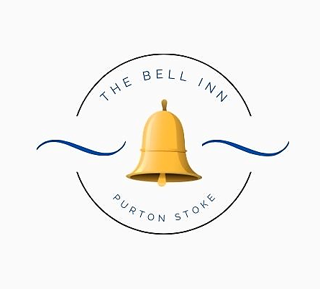

Did you know? We now serve food all day on Saturdays & Sundays. 12pm – 8pm.

All our dishes are homemade; please let us know if you have any dietary requirements or allergies, as some of our dishes can be adapted.
Every effort is made to ensure our dishes are allergen free, but there may be a possibility of cross contamination in a busy kitchen environment.

Please note a discretionary 10% service charge will be added to groups of 10 people or more.

Starters

Bowl Of Marinated Olives (V) £6

Famous Crispy Cheese Dumplings ~ With chilli jam. £8

Creamy Garlic Mushrooms ~ Served with crusty bread. (V) £8

Goan Style Prawns ~ King prawns, in a Goan style sauce, served with poppadom’s. £8

Cheese & Ham Croquettes ~ Served with garlic aioli. £8

Pub Grub Dishes

Spicy Pork Rogan Josh ~ Our homemade curry, served with coriander rice, mango chutney and poppadoms. Prefer a prawn or vegetable curry – please ask! £17

Beer Battered Cod ~ Beer battered cod, served with minted pea puree, tartare sauce, triple cooked chips & a wedge of fresh lemon. £19 Add homemade curry sauce £2.50

Wiltshire Honey Mustard Ham ~ Home cooked ham, two fried eggs and chunky chips, served with dressed leaves & coleslaw. £17

Spring Risotto ~ Peas, leeks & spinach with creamy arborio rice, finished with lemon and herb butter. £17 (V)

Bell Inn Venison Burger ~ Local 8oz venison burger, griddle cooked and served with homemade burger sauce, topped with cheese, bacon & shredded lettuce. Served in a seeded bun, with dressed leaves and seasoned fries. £17 Add a bowl of beer battered onion rings £5

Guy’s Homemade Pie ~ Please see our pie board for today’s flavour. Served with chunky chips & seasonal vegetables. £17

Fancy swapping your chunky chips to fries, mash or new potatoes? Just Ask!
Bell Inn Favourites

Fish of the Day ~ Please ask for today’s freshly cooked fish of the day.
£ Market Price

Pork Tenderloin ~ Medallions of pork, served with our hunter’s sauce of; baby onions, mushrooms, smoked bacon & red wine. Finished with our famous crispy cheese dumplings. £26

Beef & Black Pudding Stack ~ Slices of fillet steak, griddle cooked pink and stacked with slices of black pudding. Served with a creamy Madeira and mushroom sauce. £34

6oz Fillet Béarnaise ~ Black gate 6oz fillet steak, cooked to your liking and served with a ‘Bell Inn Béarnaise’ sauce. Served with seasonal vegetables & chunky chips. (Please ask if you’d like your sauce served separately) £35

Sirloin Au Poivre ~ Black gate 8oz sirloin steak, cooked to your liking, served with a creamy peppercorn sauce. Served with seasonal vegetables & chunky chips. (Please ask if you’d like your sauce served separately) £33

Lamb Wellington ~ Slow cooked lamb shoulder, rolled in herbs and parmesan, wrapped in puff pastry and finished with a red wine and redcurrant sauce. £25

Tempura Asparagus ~ Asparagus spears, lighted battered and served with a creamy wasabi dipping sauce, dressed leaves and seasoned fries. £20 (V)

Baguettes ~ £12 Each

Bacon, Brie & Cranberry
‘’Po Boy’ (Battered king prawns & tartare sauce)
Cheddar & Red Onion Chutney
Wiltshire Ham & Coleslaw
Add a bowl of Chips or Fries £5

Children’s Menu
Suitable for children age 12 and under. (Please note; these dishes will ONLY be served to children.)
Chicken Goujons, Chips & Peas
Wiltshire Ham, Egg & Chips
Mild Vegetable Curry & Rice (V)
£12 Each, includes 2 scoops of ice-cream for dessert.

Sides
Dauphinoise Potatoes £7
Truffle & Parmesan Fries £6
Cheesy Chips £6
Beer Battered Onion Rings £5
Extra Vegetables £4
Extra Sauce £2.50
Crispy Cheese Dumplings £6
Side Salad £5

