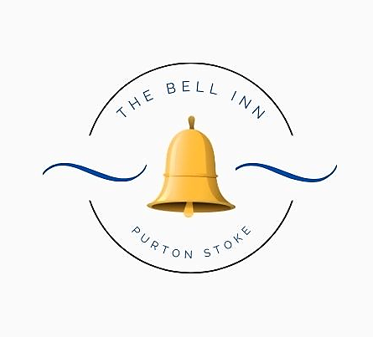

Kaileigh & Guy Tasker; formerly of The Three Crowns in Brinkworth, The Weighbridge Brewhouse, The Golden Swan and The Langley Tap welcome you to The Bell Inn, Purton Stoke.
Our goal; is to create classic British dishes with a twist and re-introduce you to some old favourites!
We hope you enjoy your meal.

All our dishes are homemade; please let us know if you have any dietary requirements or allergies, as some of our dishes can be adapted.
Every effort is made to ensure our dishes are allergen free, but there may be a possibility of cross contamination in a busy kitchen environment.

Please note a discretionary 10% service charge will be added to groups of 10 people or more.

STARTERS

Bowl Of Marinated Bosciola Olives (V) £5

Famous Crispy Cheese Dumplings ~ With sweet chilli sauce. £6

Garlic Mushrooms ~ In a creamy sauce, served on toasted baguette. (V) £6

Katsu King Prawns ~ Tempura battered king prawns, with homemade katsu dipping sauce. £8

Liver & Bacon Pâté ~ Topped with truffle butter, Served with red onion chutney & crusty bread. £7

MAINS

Madras Curry ~ Our homemade spicy and tangy madras curry, served with coriander rice, mango chutney and poppadoms. Choose from; Lamb, King Prawns or Vegetable. (V) £19

Beef Shin ~ Slow cooked, boned and rolled shin of beef, served on a bed of rosemary mash potato, with a rich red wine and redcurrant gravy. £22

Fish of the Day ~ Please ask for today’s freshly cooked fish of the day. £ Market Price

Guy’s Homemade Pie ~ Please see our pie board for today’s flavour. Served with chunky chips. £19

Mushroom & Stilton Wellington ~ A whole portobello mushroom, stuffed with spinach, onion & stilton, wrapped in puff pastry, served with a horseradish, white wine & cream sauce. £20 (V)

Pork Tenderloin ~ Medallions of pork, served with our hunter’s sauce of; baby onions, mushrooms, smoked bacon & red wine. Finished with our famous crispy cheese dumplings. £26

Beer Battered Haddock ~ Beer battered haddock, served with minted pea puree, tartare sauce, triple cooked chips & a wedge of fresh lemon. £19 Add homemade curry sauce £2.50

Chicken En Croute ~ A large chicken breast, stuffed with cheddar cheese, smoked bacon & cracked black pepper. Wrapped in puff pastry and baked until golden. Served with a creamy white wine and tarragon sauce. £25

Corn Ribs ~ Seasoned with paprika, lightly fried and tossed in garlic butter, served with spicy buffalo mayo, fries & salad garnish. £16 (V)

Wiltshire Hot Pot ~ Pork, slow cooked with leeks, bacon, cider & cream, topped with herb and parmesan mash, and baked until golden. £19

Beef & Black Pudding Stack ~ Slices of fillet steak, griddle cooked pink and stacked with slices of black pudding. Served with a creamy Madeira and mushroom sauce. £32

Steak Au Poivre ~ Black gate 8oz sirloin steak, cooked to your liking and served with a rich & creamy peppercorn sauce. Served with seasonal vegetables & chunky chips. (Please ask if you’d like your sauce served separately) £30

Why not upgrade your chips?

~ Truffle & Parmesan Fries
~ Cheesy Chips
£2.50 per upgrade

SIDES
Crispy cheese dumplings £6
Beer battered onion rings £5
Bowl of seasonal vegetables £4.50
Extra sauce £2.50

YOUNGER GUESTS

Suitable for children age 12 and under. (Please note; these dishes will ONLY be served to children.)

Fish & Chips ~ Battered haddock, served with chunky chips and peas.
Sausages, Chips & Peas ~ Two butchers sausages, served with chunky chips and peas.
Cheesy Garlic Baguette ~ Served with chunky chips and peas. (V)

All including 2 scoops of ice-cream for dessert. Please ask for our flavours board.
£12 Each

