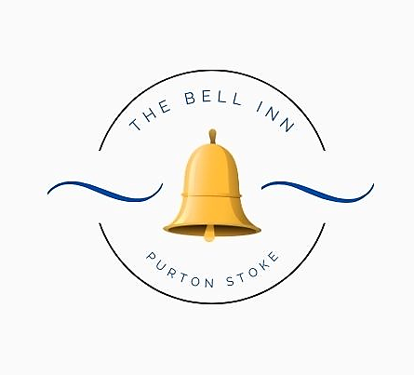

All our dishes are homemade; please let us know if you have any dietary requirements or allergies, as some of our dishes can be adapted.
Every effort is made to ensure our dishes are allergen free, but there may be a possibility of cross contamination in a busy kitchen environment.

Please note a discretionary 10% service charge will be added to groups of 10 people or more.

Starters

Bowl Of Marinated Bosciola Olives (V) £5

Famous Crispy Cheese Dumplings ~ With chilli jam. £6

Creamy Garlic & Stilton Mushrooms ~ Served with toasted bread. (V) £6

Drunken Prawns ~ King prawns, in a creamy sauce, flavoured with a dash of Jägermeister, served with crusty bread. £8

Chicken Liver Pâté ~ Served with red onion chutney & crusty bread. £7

Pub Grub Dishes

Goan Style Curry ~ Our homemade creamy Goan style curry, served with coriander rice, mango chutney and poppadoms. Choose from; King Prawns or Vegetable. (V) £16

Beer Battered Cod ~ Beer battered cod, served with minted pea puree, tartare sauce, triple cooked chips & a wedge of fresh lemon. £16 Add homemade curry sauce £2.50

Bubble & Squeak ~ Traditional potato, onion and cabbage, pan fried and topped with home cooked Wiltshire ham and a brace of fried eggs. £16

Bell Inn ‘Posh Scampi’ ~ King prawns, lightly battered and served with chunky chips, minted pea puree and homemade tartare sauce. £16

Crispy Portabello Mushrooms ~ Lightly battered strips of portabello mushroom, with a 3B ale & cheese dip, served with side salad and skinny fries. £16 (V)

Buffalo Chicken Burger ~ Spicy marinated chicken breast, crispy coated in our own herbs and spices. Double stacked and topped with Monterey jack cheese. Served with lettuce, homemade coleslaw and French fries. £16

Guy’s Homemade Pie ~ Please see our pie board for today’s flavour. Served with chunky chips. £16

Bell Inn Favourites

Lamb Shoulder ~ Slow cooked, boned and rolled, served on a bed of pea puree, with a minted white wine sauce. £22

Fish of the Day ~ Please ask for today’s freshly cooked fish of the day.
£ Market Price

Pork Tenderloin ~ Medallions of pork, served with our hunter’s sauce of; baby onions, mushrooms, smoked bacon & red wine. Finished with our famous crispy cheese dumplings. £26

Beef & Black Pudding Stack ~ Slices of fillet steak, griddle cooked pink and stacked with slices of black pudding. Served with a creamy Madeira and mushroom sauce. £34

Fillet Rossini ~ Black gate 6oz fillet steak, cooked to your liking and served with a traditional Rossini sauce, on a pate topped crouton. Served with seasonal vegetables & chunky chips. (Please ask if you’d like your sauce served separately) £34

Sirloin Au Poivre ~ Black gate 8oz sirloin steak, cooked to your liking, served with a creamy peppercorn sauce. Served with seasonal vegetables & chunky chips. (Please ask if you’d like your sauce served separately) £32

Mexicana Mac ‘N’ Cheese ~ Peppers, tomato, mushroom and spinach, tossed in a creamy sweet chilli & cheddar cheese sauce, baked in the oven and served with garlic bread and a side salad. £16 (V)

Fancy swapping your chunky chips to fries, mash or new potatoes? Just Ask!

Baguettes ~ £10 Each
Available at lunchtimes only
Bacon, Brie & Cranberry
‘Posh Scampi’ & Tartare Sauce
Cheddar & Red Onion Chutney
Wiltshire Ham & Coleslaw
Add a bowl of Chips or Fries £5

Children’s Menu
Suitable for children age 12 and under. (Please note; these dishes will ONLY be served to children.)
‘Posh Scampi’, Chips & Peas
Wiltshire Ham, Chips & Peas
Mac ‘N’ Cheese ~ with garlic bread
£12 Each, includes 2 scoops of ice-cream for dessert.

Sides
Dauphinoise Potatoes £7
Truffle & Parmesan Fries £6
Cheesy Chips £6
Beer Battered Onion Rings £5
Extra Vegetables £4
Extra Sauce £2.50
Crispy Cheese Dumplings £6
Side Salad £5

